**CCT College Dublin**

# **Assessment Cover Page**

|  |  |
| --- | --- |
| **Module Title:** | Client-Side Programming |
| **Assessment Title:** | CA2 |
| **Lecturer Name:** | Sam Weiss |
| **Student Full Name:** | Bárbara Candido de Souza |
| **Student Number:** | 2023059 |
| **Assessment Due Date:** | *Sunday 19th May 2024 @ 23:59* |
| **Date of Submission:** | *Sunday 19th May* |

**Declaration**

|  |
| --- |
| By submitting this assessment, I confirm that I have read the CCT policy on Academic Misconduct and understand the implications of submitting work that is not my own or does not appropriately reference material taken from a third party or other source. I declare it to be my own work and that all material from third parties has been appropriately referenced. I further confirm that this work has not previously been submitted for assessment by myself or someone else in CCT College Dublin or any other higher education institution. |

Table of Contents

**Assessment Cover Page** 1

Introduction 3

Changing to ReactJS and Vue.js 3

ReactJS vs. Vue.js 5

Conclusion 5

**Report**

Outlining the fundamentals of client-side programming for adding dynamic content this website.

# Introduction

In this assignment I developed a game called Monster Mayhem using HTML, CSS and JavaScript. The game consists in a 10 by 10 grid of hexagons which each player takes turns to select a hexagon. The game ends by either selecting a losing hexagon or taking more than 5 seconds to select one.

In this report I’ll be discussing the differences and similarities of two famous frameworks, React and Vue, and giving an example on how I could implement one or the other in this code.

ReactJS is an open-source JavaScript library utilized for managing the view layer in both Web and Mobile applications. It can be operated on the server-side as well as the client-side. Vue.js is a JavaScript front-end framework. Vue.js is a progressive framework for web UI (geeksforgeeks, 2023), it is designed to be integrated with existing projects (Vue, 2024).

Both React and Vue are for building user interface out of individual pieces called components. React components are JavaScript functions that return as markup mostly with JSX (React, 2024). While Vue is built on top of standard HTML, CSS and JavaScript (Vue, Introduction, 2024).

# Changing to ReactJS and Vue.js

In my website I could use the frameworks to create components such as Header, Instructions, Hexagon, HexGrid, InfoPanel, RestartButton, LosingImage and Footer. By creating each individual component for my website, I can maintain a modular and organized application. Being easier to manage and scale the codebase. Each component will have its own functionality and styling, allowing for better reusability and scalability.

An example of implementing React (GPT, 2024) and Vue (GPT, 2024) to create the HexGrid for the game according to Chat GPT:

* **Hexagon Component**

Represents each hexagon of the grid. I could add logic such as different states for selected, player1, payer2, or losing.

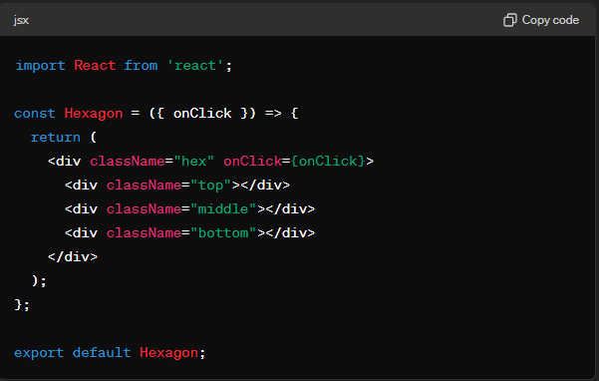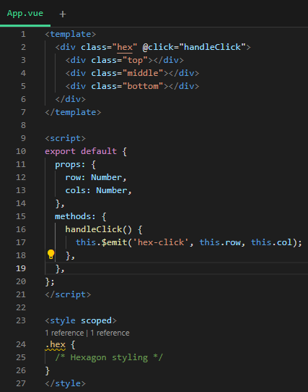

* **HexGrid component**

Which would generate a grid containing the logic for handling clicks on each hexagon.

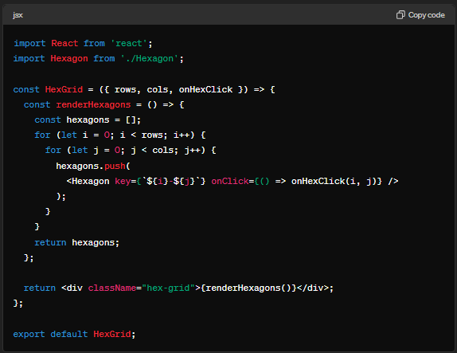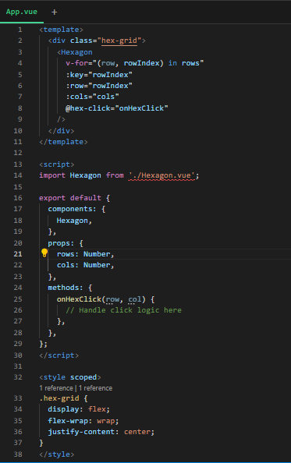

* **App component**

Using the HexGrid component in the App to handle clicks on hexagons

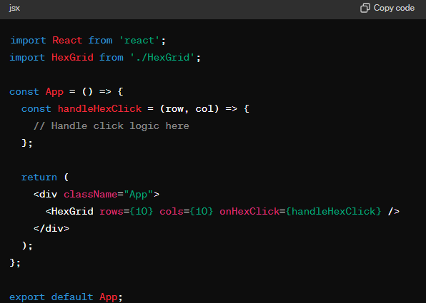 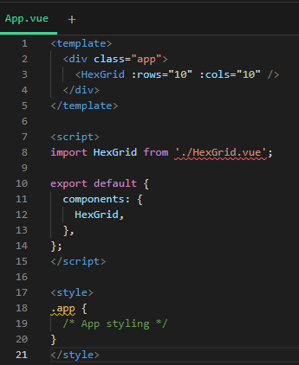

# ReactJS vs. Vue.js

I’ll compare both frameworks using the hex grid codes shown in Changing to ReactJS and Vue.js. In React, everything is written in JavaScript. HTML and CSS management structures are expressed via JSX. This approach brings benefits like the power of a full programming language to build my website. This includes temporary variable, flow controls, and directly referencing JavaScript values in scope. Also, the tooling support that is more advanced then Vue templates. However, this approach could have its disadvantages.

On the other hand, Vue embraces classic web technologies making it easier for less experienced developers feel more natural to read and write for having a HTML based templates and creating the migration process less complicated for them (Vue, 2024).

React also allows better scalability for example: breaking down the hex grid into smaller, manageable components, which can be scaled as the application grows like each hexagon and the grid itself are separate components. (Smith, 2023)

Vue's reactivity system, which automatically updates the DOM when data changes, offers a simpler approach to managing application state. Vue provides various ways to apply transitions to elements when they are added or removed from the DOM like a transition system to add effects to the hex grid. (geeksforgeeks, 2023)

The key difference between both is React JS is a library, while Vue is a JavaScript framework. As a library, React provide users additional options, such as manual rendering and it extensive use of functional programming techniques, as shown by the manipulation of library state and interaction between components making it possible to add more and better features to my website if it’s needed. Vue features a more classic syntax, which if I change my game to Vue the development process would be easier (Smith, 2023).

# Conclusion

In conclusion, both React and Vue have their strengths and advantages, making them suitable for different development scenarios. React's extensive tooling support, flexibility, and focus on functional programming techniques provide developers with robust capabilities to build complex and scalable applications. On the other hand, Vue's simplicity, great documentation, a more natural to read and write and intuitive reactivity system make it an excellent choice for projects small like this one and for individuals new to framework, such as first-year IT student like myself could easily implement Vue to this assignment code.

References

geeksforgeeks. (2023). *Difference between ReactJS and Vue.js*. geeks for geeks. Available at: https://www.geeksforgeeks.org/difference-between-reactjs-and-vue-js/

GPT, C. (2024, May 17). Chat GPT. Available at: https://chatgpt.com/Prompt:How could I use react to build my grid

GPT, C. (2024, May 17). Chat GPT. Available at: https://chatgpt.com/ Prompt: "Now with vue"

React. (2024). *The library for web and native user interfaces*. React . Available at: https://react.dev/learn

Smith, A. (2023). *React vs. Vue: A Complete Comparison to Know*. Medium. Available at: https://web-and-mobile-development.medium.com/react-vs-vue-a-complete-comparison-to-know-4038abf117d7

Vue. (2024). *Comparison with Other Frameworks*. Vue.js. Available at: https://v2.vuejs.org/v2/guide/comparison.html?redirect=true

Vue. (2024). *Introduction*. =Vue.js. Available at: https://vuejs.org/guide/introduction.html

Vue. (2024). *Introduction*. Vue.js. Available at: https://v2.vuejs.org/v2/guide/